Analysis of the Unemployment Rates of New Jersey, New York and Pennsylvania from 2019 to 2021

Upon viewing the graphs below, we are able view the average changes in unemployment rates for New Jersey, New York, and Pennslyvania from January 2019 until May of 2021. We will see how Covid-19 had a massive impact on all 3 states starting in April of 2020 with a slight recovery by December of 2020.

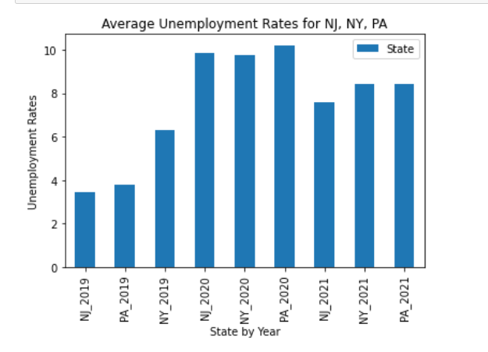

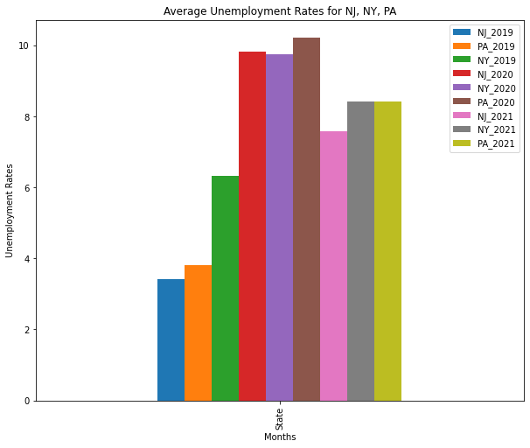

From January 2019 until March 2020, the unemployment rates were within the 3.0 to 4.0 range with Pennsylvania and New York relatively even in their unemployment rates. Both states hover between a steady 3.8 to 3.9 rate for the duration of the year. New Jersey remained slightly lower, ranging between the 3.5 to 3.6 mark.

Once the pandemic hit in March of 2020, both Pennsylvania and New Jersey unemployment trippled in their rates to the 15 to 16 point range, leaving New York remaining at a lower rate of 3.9. It was not until May of 2020 that we were able to see a significant impact with New York and Pennsylvania’s unemployment rate rising to the 16.0 range

* New Jersey had a slightly better recovery starting in September of 2020 dropping just below the 10.0 range.
* New York had a massive decrease by November and December of 2020, rising again in January of 2021 to the 10.0 range, only to gradually decrease within the 8 to 7 point range.
* The New York unemployment rate remains the highest of each state throughout the 3 years.
* Pennslyvania and New York unemployment rates remain slightly higher than New Jersey post- recovery 2021 thus far.

